****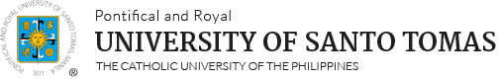**University of Santo Tomas**

**College of Education**

**Bachelor of Library and Information Science Program**

**CONFORME**

This is to certify that I, ___________________________________________________ , a student of

(name)

Bachelor of Library and Information Science (BLIS), have read and fully understood the policy statements and guidelines contained in the **Handbook of Standards and Practices in Undergraduate Practicum of the Library and Information Science Program.** I hereby declare that I shall abide by the said policy statements and guidelines and that failure to comply in any of the said policy statements and guidelines will merit me a corrective action/s stipulated in the Handbook.

**__________________________________________**

**Signature above printed name of student**

**_____________________________**

**Date**